**SQL**

**(DDL AND DML COMMANDS)**

S.R TAANUSRI

**1.Creating the tables:**

* By using the create keyword two tables America and India are created.
* There are 5 attributes used : name, age, sex, state, id.
* Based on the attribute type the data type and the data size is decided and used

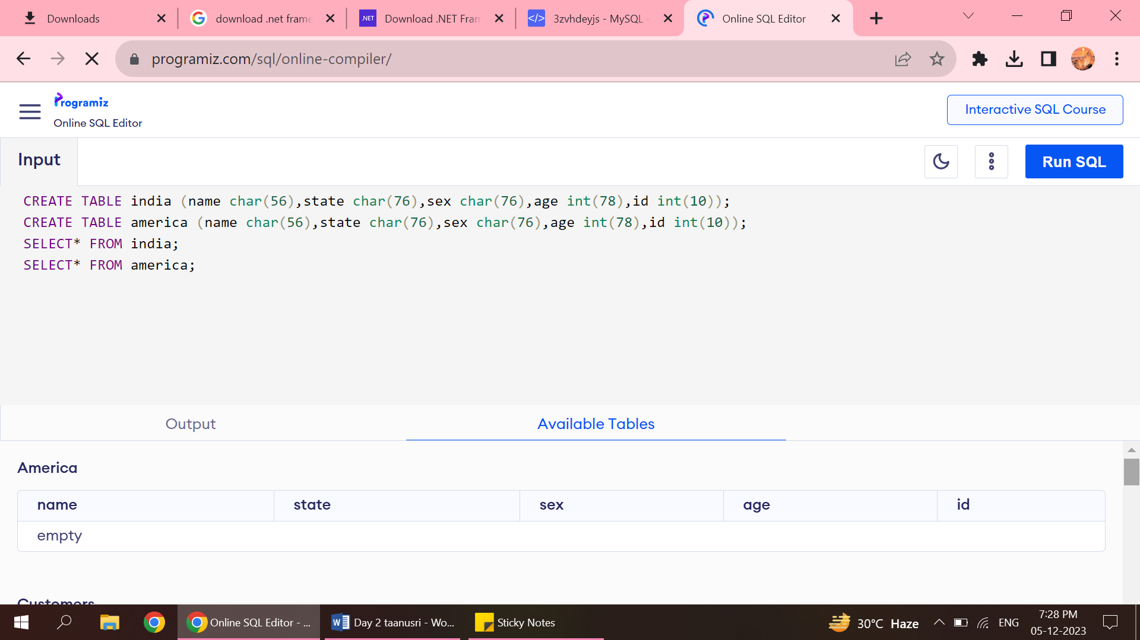

**2.Showing the tables:**

* Show the tables names.

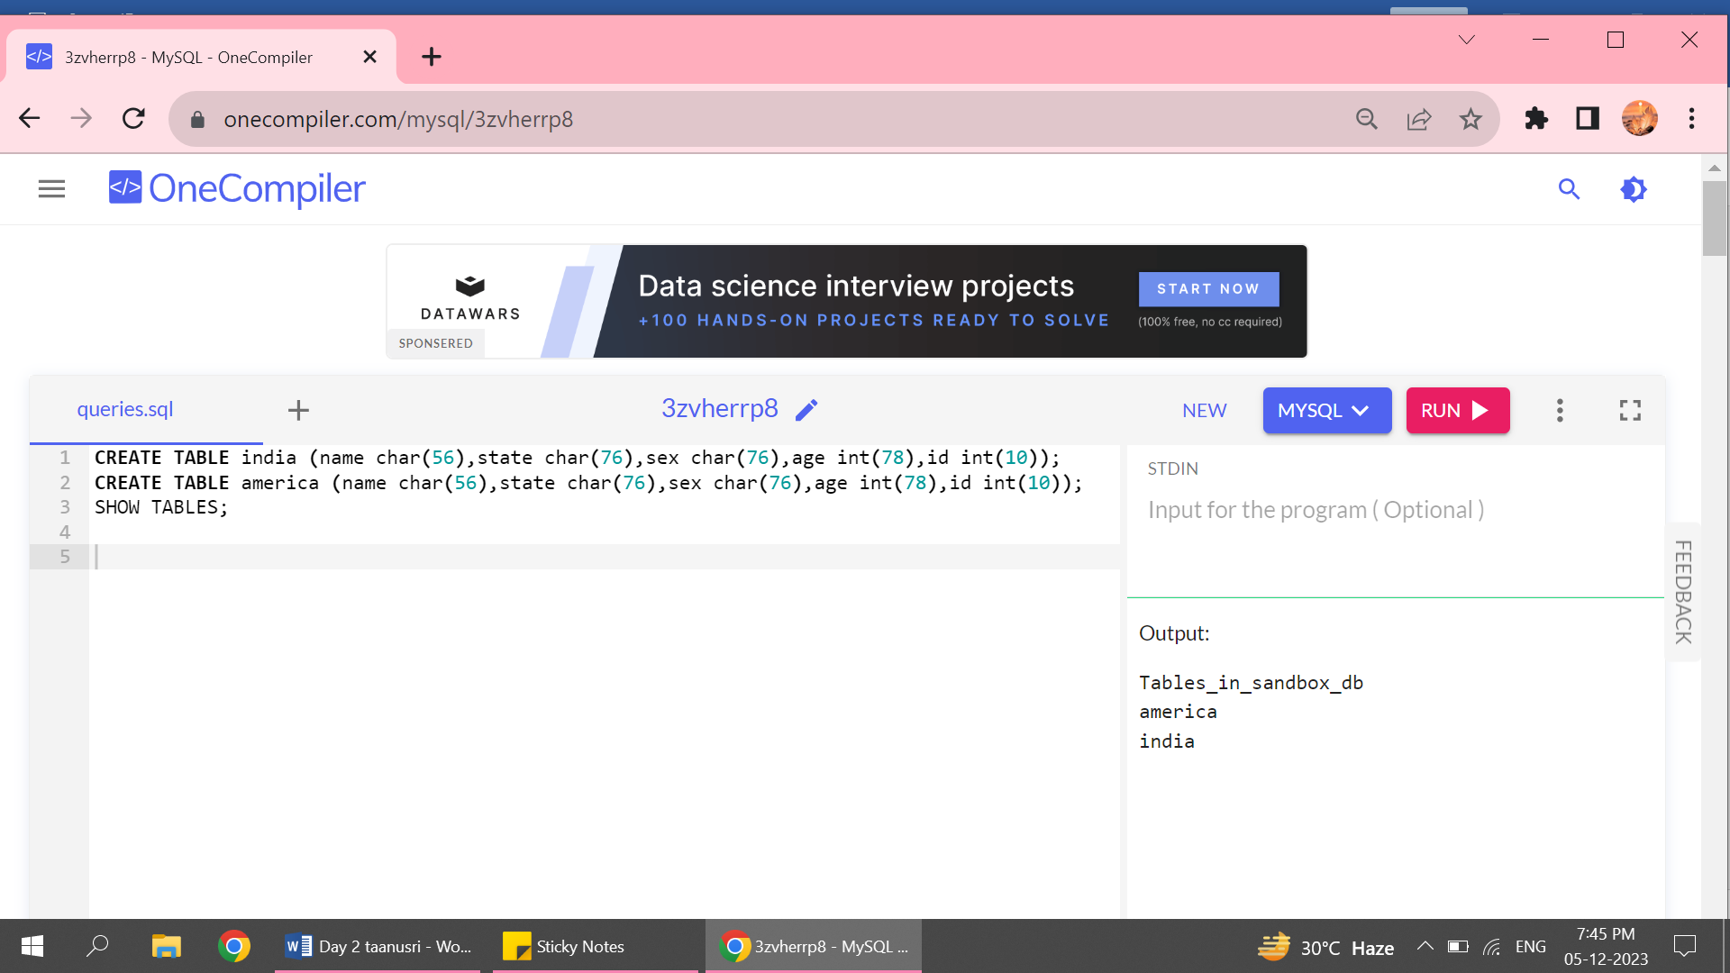

**3.Inserting the values into table:**

* Based on the key -value, values are inserted into tables.
* The key value is entered for every pairs based on the attribute data type and data size.
* Now the table can be viewed with the values entered inside it.

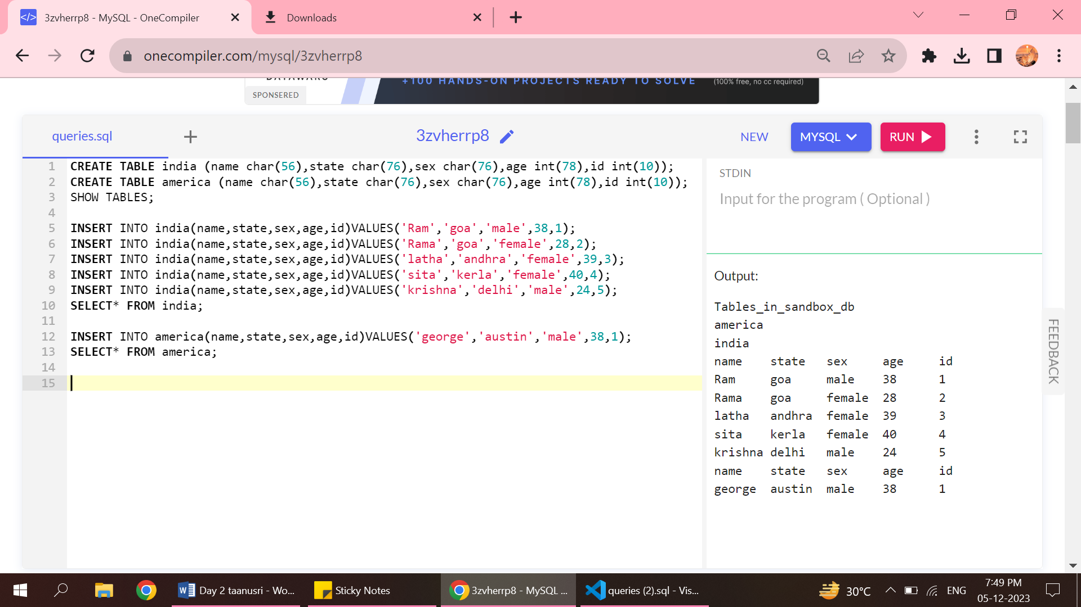

**4.Selecting query with WHERE clause:**

* The condition is given using the where clause
* It checks whether the sex is female and if the condition is true then the age of the person is returned.
* The select gives the particular columns which contains the required age.

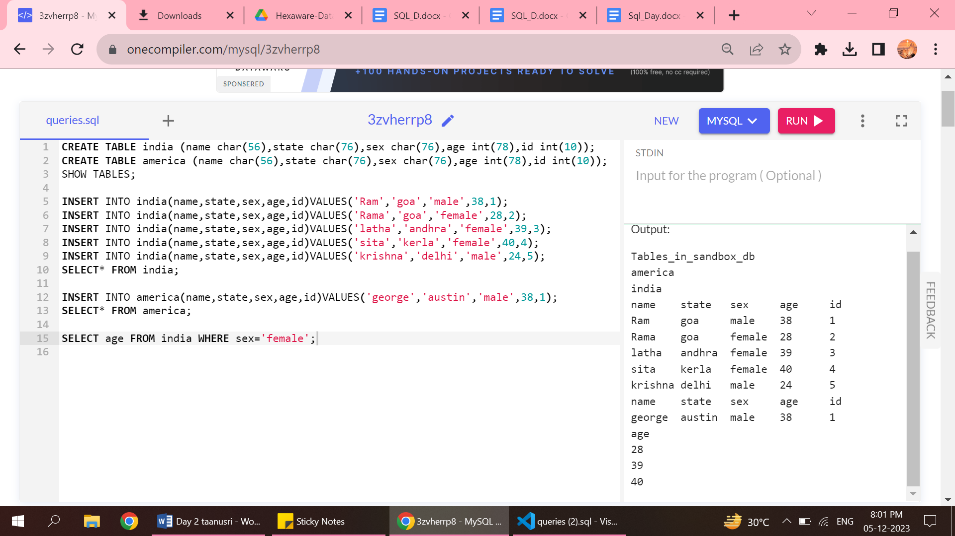

**4.Updating a query with WHERE clause:**

* If a particular value needs to be updated in the table instead of the value already entered, then update command is used.
* So the new value that needs to be updated is mentioned with SET keyword and in the place where the value has to be updated is mentioned with where clause.

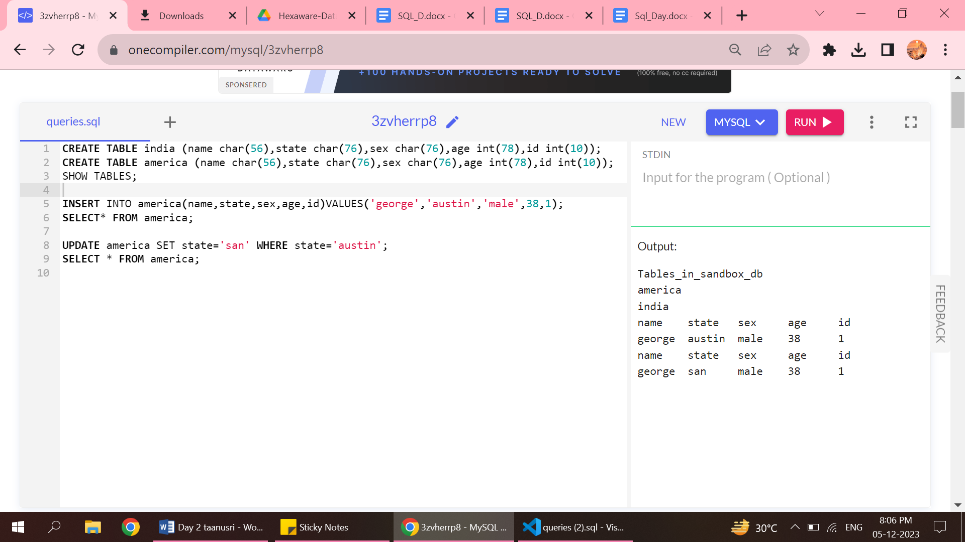

**5.Sorting data with ORDER BY:**

* With help of this order by keyword can be sorted in the ascending or descending order.
* This helps us for the quick viewing on the data for the specific condition given.

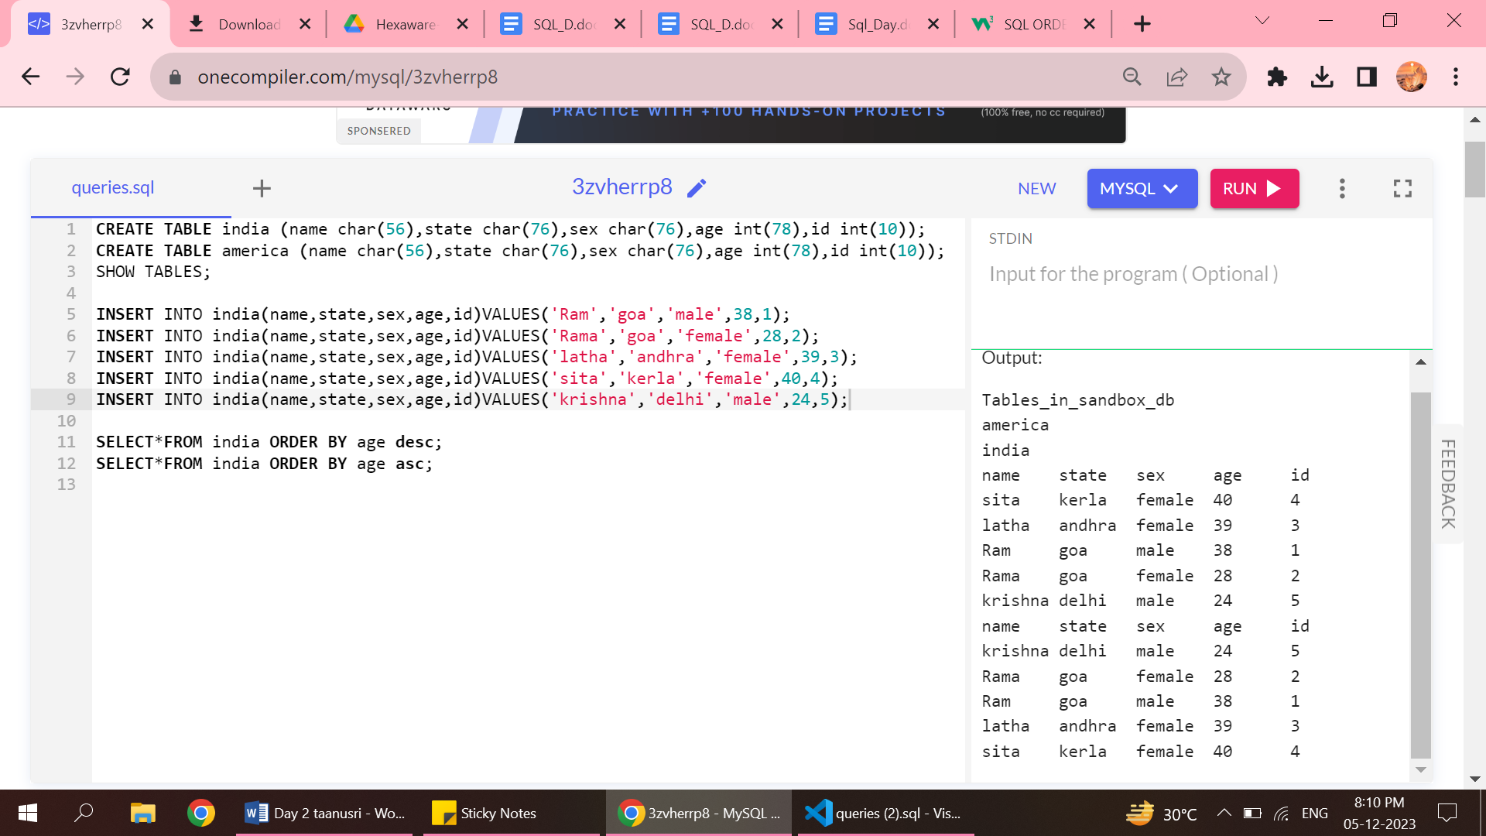

**6.Altering a table by adding a new column:**

* In order to add a new column in a existing table, first the table should be altered with alter keyword.
* Then the new column that needs to be added should be specified.

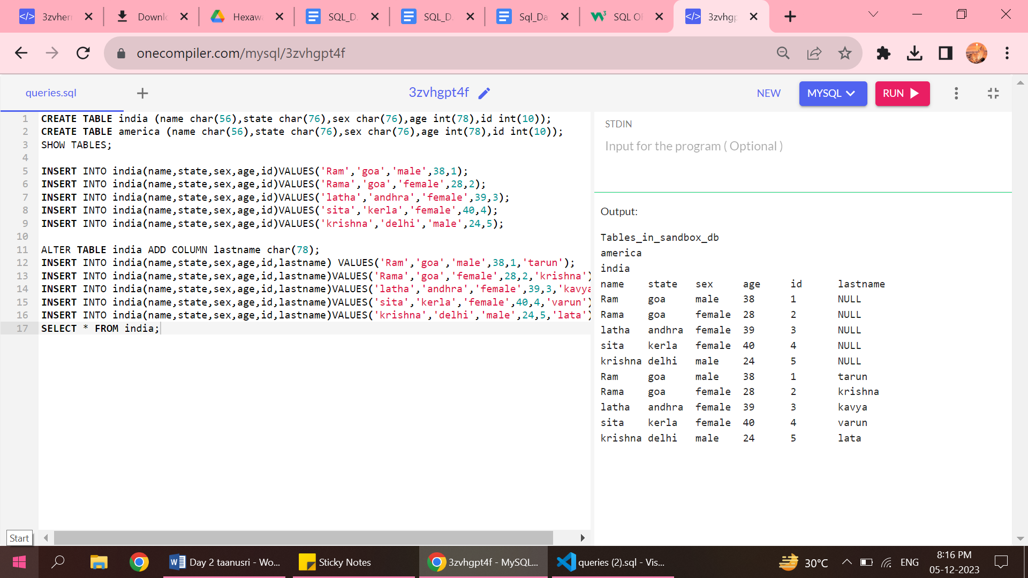

**7.Altering a table by dropping a column:**

* Some times while entering the data, some columns might be extra or unwanted.
* That can be deleted from the table using the drop command.

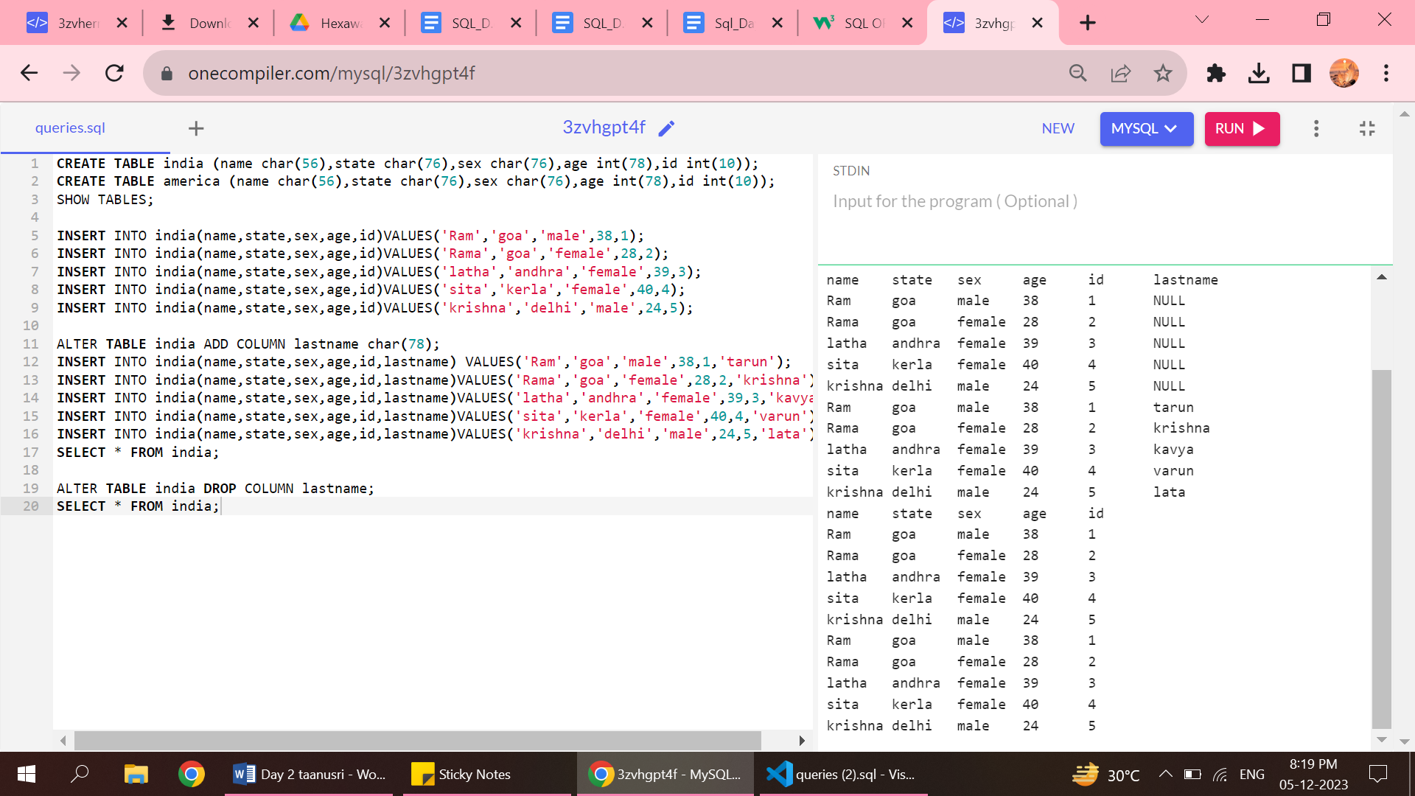

**8.Removing unwanted data with DELETE:**

* The unwanted can be deleted from a table by specifying the condition where the data needs to be removed by using the appropriate clause.

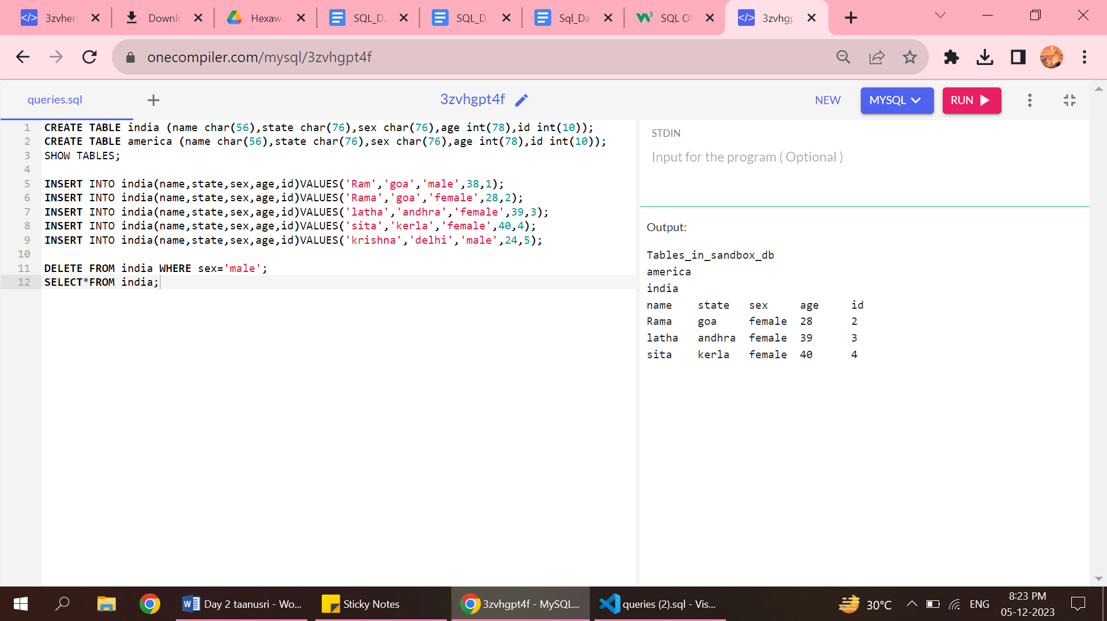

**9.Renaming the column:**

* A particular row or column can be renamed if the user detail data value are changed from the table.

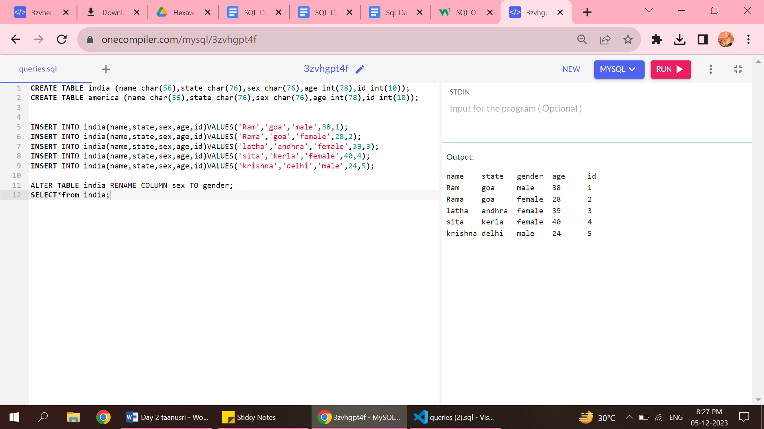

**10. TRUNCATE :**

* If the value inside the entire table needs to be deleted then truncate command is used.
* But the table remains only the value entered get deleted.

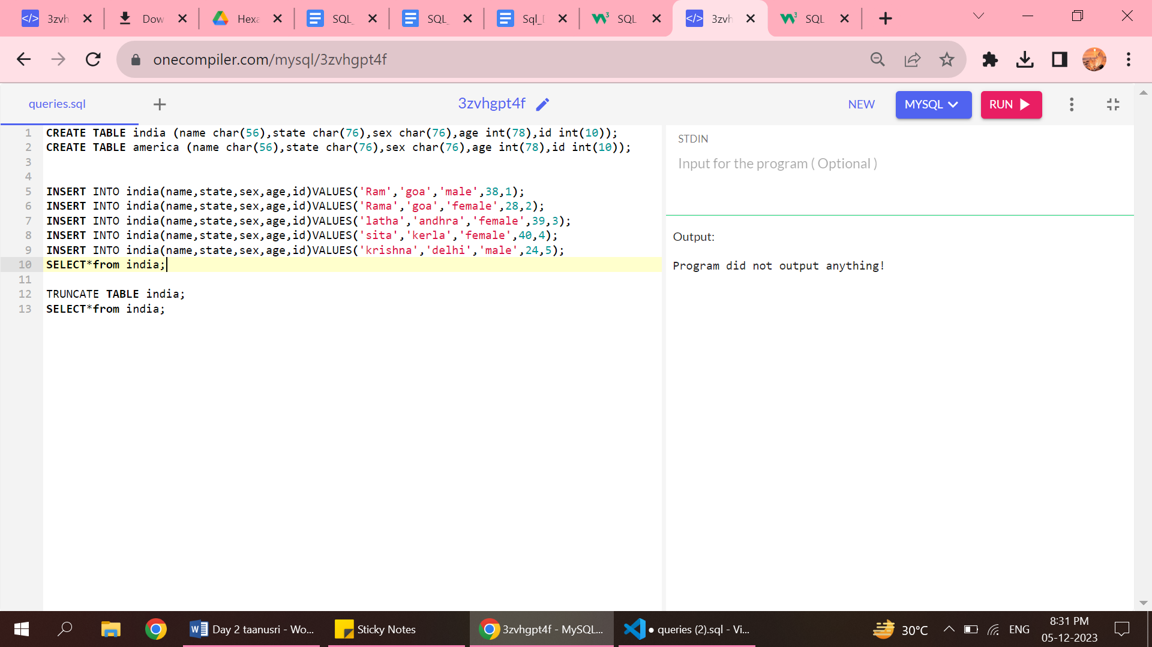

**11. JOIN :**

* The two different tables are joined for the better understanding.
* For joining two tables JOIN keyword is used which specifies name of the two tables that need to be joined .
* The FROM keyword specifies from which table(eg: table A) to which table (eg: table B)should be joined and the ON keyword specifies which two items have the same key value.
* To join two different tables, the should have the same key values in both the tables.

